**Date: 01.05.2**Line**4 to 05.05.24**

**Time: 02:00PM to 10:30AM**

**Name:** Industry Visit to Tangentia, Goa

**Objective:**

* **Understand Real-World Applications of Automation and AI:** To observe firsthand how advanced technologies such as robotic process automation (RPA) and artificial intelligence (AI) are applied in business solutions, enhancing operational efficiency and decision-making processes.
* **Explore Industry-Specific Technology Implementations:** To gain insights into how Tangentia tailors its technological solutions to different sectors, including finance, healthcare, and retail, thereby understanding the versatility and impact of AI and automation across various industries.
* **Interact with Industry Professionals:** To engage with experts and professionals in the field of digital transformation, gaining career-oriented knowledge and understanding the skills required to succeed in the technology and automation industry.

**Description:**

**Visit Background:** A group of 25 pre-final year BTech CSE students from the AIML and Cybersecurity departments at Jain Deemed-to-be University in Jayanagar, 9th Block, participated in an industry visit to Tangentia in Goa. Accompanied by three faculty members, Prof. Renuka Devi, Ms. Dilchashmi, and Mr. Shanti Kumar, and a female travel agent, Ms. Navya, the visit aimed to provide students with insights into real-world business applications of digital transformation technologies.

**Introduction to Tangentia:** The HR representative at Tangentia provided a detailed presentation about the company. The session covered the company's foundation, its commitment to agile digital transformation, and its strategic use of technologies such as Robotic Process Automation (RPA) and Artificial Intelligence (AI). The discussion also touched upon the hybrid work model adopted by Tangentia, reflecting a modern approach to work-life balance and employee productivity.

**Focus on AI and RPA:** The presentation was insightful about the integration of AI and RPA within various business processes. Students learned how Tangentia uses AI to automate complex data analysis tasks, enhance decision-making, and improve customer interactions through advanced analytics and machine learning models. Regarding RPA, the emphasis was on how these technologies automate repetitive tasks, streamline operations, and reduce costs, thereby enhancing business efficiency.

**Agile Practices and Project Management:** Tangentia's adoption of agile methodologies was also discussed, showcasing how the company remains flexible and responsive to client needs through iterative development and continuous feedback. This approach is crucial in technology projects where evolving requirements and rapid changes are common.

**Interactive Learning and Q&A Session:** Students engaged in a Q&A session where they explored challenges faced by Tangentia in global projects, such as language barriers in the Mexico project. The solution involved strategic hiring to improve communication and project outcomes. Another discussion highlighted a project for a Canadian government agency, emphasizing how Tangentia automates retail processes to improve governmental operations.

**Educational Value:** This visit provided the students with an opportunity to see the application of their academic knowledge in AI, cybersecurity, and agile project management in a real-world context. The discussions helped them understand the technological adaptability required in professional settings and offered insights into potential career paths in the technology and digital transformation sectors.

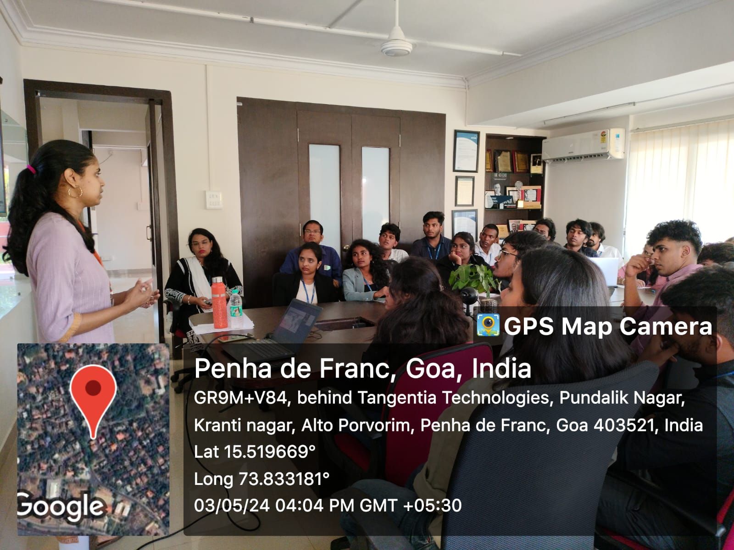

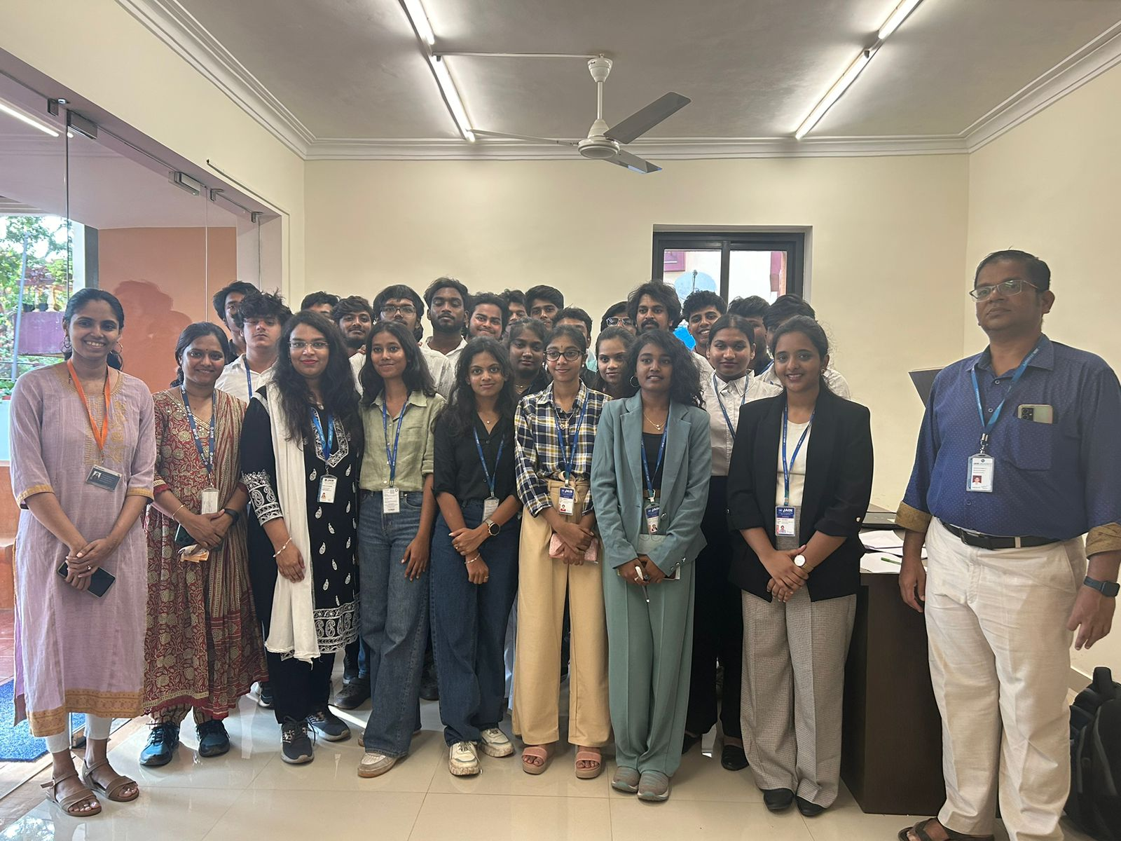

**Itinerary of the Industrial Visit to Goa**

**Day 1: May 1, 2024**

* **2:00 PM**: Students gathered at Jain Deemed-to-be University to sign necessary documents and prepare for the trip.
* **3:30 PM**: Departure from the university. The group included 25 students, two female faculty members, and a travel agent.
* **5:00 PM**: Stopped on the way to pick up Mr. Shanti Kumar.
* **7:00 PM**: Refreshment break at Kalpatharu Veg Restaurant in Tumkur District.
* **9:00 PM**: Dinner at Gurjent Punjabi Dhaba, featuring traditional seating and a unique dining experience.

**Day 2: May 2, 2024**

* **6:00 AM**: Arrival in Goa, greeted by the scenic views of forested hills.
* **6:40 AM**: Checkpoint stop for permit verification and refreshments.
* **8:50 AM**: Check-in at The Royal Assagao resort. Exploration of resort facilities followed by breakfast around 9:30 AM.
* **10:30 AM**: Post-breakfast, students engaged in recreational activities at the resort, utilizing facilities like the pool table and board games, fostering teamwork and relaxation.
* **1:30 PM**: Lunch at the resort.
* **3:00 PM**: Trip to Calangute Beach; activities included beach games and relaxation.
* **6:00 PM**: Return to resort for freshening up.
* **9:00 PM**: Dinner at the resort, followed by social games like Uno.

**Day 3: May 3, 2024**

* **7:00 AM**: Morning swim at the resort's pool.
* **9:30 AM**: Breakfast, followed by a visit to a local fort.
* **2:00 PM**: Lunch at the resort.
* **3:00 PM**: Departure for the industrial visit to Tangentia, completed around 5:40 PM.

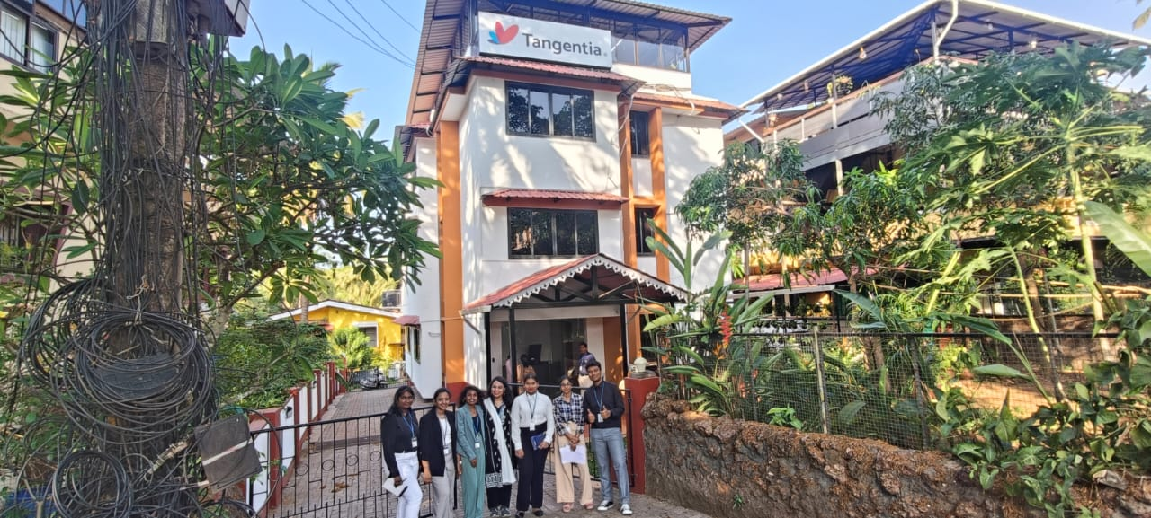

* **6:00 PM**: Lake cruise in Panjim, offering serene views and relaxation.
* **8:30 PM**: Return to the resort for dinner.

**Day 4: May 4, 2024**

* **Morning**: Leisure time in the pool, followed by breakfast at 9:30 AM.
* **11:30 AM**: Visit to Aguada Fort, enriching the group with historical insights.

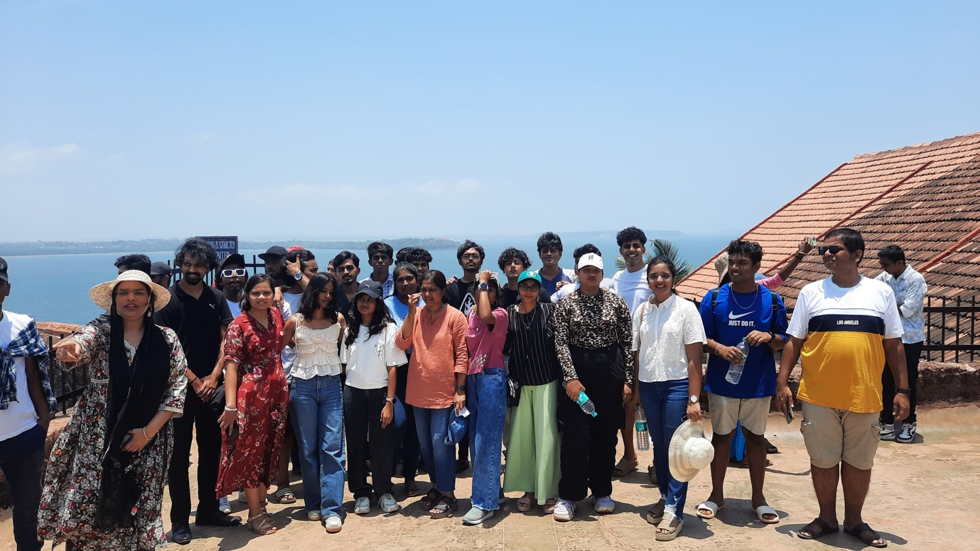

* **3:30 PM**: Exploration and shopping at Anjuna Beach, known for its rocky landscape and sea life.
* **5:40 PM**: Departure from Anjuna Beach.
* **10:30 PM**: Dinner near the Goa-Karnataka border, concluding the day's activities.

**May 5, 2024**

* **Morning**: Return journey to Bangalore, concluding the enriching and educational visit. The students and faculty reported back to the university, bringing with them valuable insights and memorable experiences from their visit to Goa.

**Conclusion:** The industry visit to Tangentia served as a significant educational experience, bridging the gap between academic concepts and their practical applications in the technology industry. It enriched the students' learning journey, preparing them for future professional challenges in a digitally transforming world.

Industrial Visit Coordinators Program Head

AIML & Cyber Security

(Jayanagar Campus)